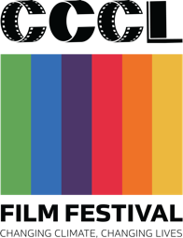

CCCL Film Fund: Application Form

The theme for the CCCL Film Festival is “Making Peace with Nature”

CCCL Film Festival 2021

Please read and follow the submission guidelines for your application at www.ccclfilmfestival.com/grants
For general inquiries, please contact submissions@ccclfilmfestival.com

Section 1 Applicant General Information
Team Leader (contact person)
Name
Nickname |  |  |  |  |  |  | Age |  |  |  | Year Birthday
Address
Province |  |  |  |  |  | Postal Code
Tel. |  |  |  |  | Facebook
Line |  |  |  |  | Email
Occupation

Education Ballot box with X symbol
 | Elementary |  | Lower-secondary |  | Upper-secondary/TVE |  | Undergraduate |  | Graduate

Gender Ballot box with X symbol |  | Male |  | Female |  | LGBTQ+/non-binary

Are you a member of ethnic minorities Ballot box with X symbol
 | ใช่ |  | ไม่ใช่

Are you and your team members a student(s)? Or are you under the age of 21?

Ballot box with X symbol
 | Yes |  | No

Are you a teacher who will act as an advisor for a project?

Ballot box with X symbol
 | Yes |  | No

Fill in a name of your school and province (If you’re a student or a teacher)

Have you experienced making a film before?

Ballot box with X symbol
 | Yes |  | No

Are you interested in the mentorship program?

(Answer only you’re under 21 years old or don’t have experience in filmmaking before)

A Mentorship Program allows selected participants (up to 10 projects) to be matched with film professionals (mentors) who will help developing the story and give advice on a monthly basis. (Ballot box with X symbol)
 | I’m interested |  | I’m not interested

Please explain.

Section 2 Project proposal

Project Title

Project Title in English (if any)

Director name(s)

In case a team leader isn’t a director, or a project has more than 1 director.

Type of Film

Ballot box with X symbol
 | Fiction/Narrative |  | Animation |  |  | Documentary
 | Experimental film |  | อื่น ๆ ระบุ

Logline

Synopsis

Budget Plan

Explain how you will be using the THB 25,000 grant
Items | Total Cost (Baht)
(i.e. Camera equipment rental) | (i.e. 5,000 )

Visual References
(Text and images can be deleted)
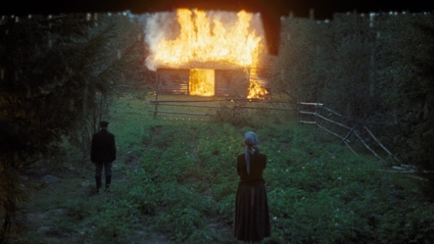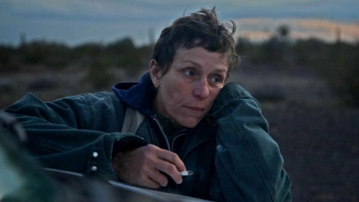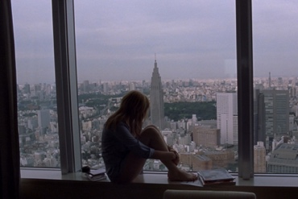

Director statement

An applicant must explain how your film relates to climate change and why it’s important for you to tell this story. Also explain your vision and idea of your story.

Director and Team Member Bios

Link to your previous work

If you don’t have the previous work, please explain your interest in film, and give examples of 2-3 films that you like. Identify the features of the film that created impacts and explain why.

Fill in the form and upload all requested documents to submisssions@ccclfilmfestival.com with subject “CCCL Film Fund 2021 - (Your project name)” ex. “CCCL Film Fund 2021 - Storm of Love”

The deadline to submit project proposal(s) to the CCCL Film Fund Program is April 30, 2021 at 11.59 PM (GMT+7). Applications received after this date and time will be ineligible.

For any inquiries
Email submissions@ccclfilmfestival.com
Facebook: https://www.facebook.com/ccclfilmfest
Website: https://www.ccclfilmfestival.com

ENTRY CONDITIONS
- Applicants declare that he/she/they owns the copyright for the sample of work submitted.
- Applicants may submit more than one project proposal. Only one project made by the same applicant will be chosen.
- New to this year, applicants under 21 years old or without a filmmaking background can opt-in to participate in a mentorship program receiving guidance from mentors on filmmaking aspects. CCCL Film Festival will be revealing lists of mentors later.
- Grants will be allocated according to achieving milestones i.e. script approval, set up expense, shooting expenses. The grantees should complete their scripts by June 30, 2021. The CCCL Film Festival may give you suggestions on the projects, but we will never interfere with your artistic choices.
- Applicants must deliver a complete film to CCCL Film Festival no later than September 24, 2021. Late delivery will be granted on a case-by-case basis.
- Upon delivery, the total length of a complete film must not exceed 15 minutes.
- All film projects produced in the CCCL Film Fund program will be co-owned by CCCL Film Festival. The grantees grant CCCL Film distribution rights, including showing at third party events or venues, using the films for promotion, marketing, and entering the films in other film festivals by governmental and non-governmental organizations. The festival may also have the right to screen the grantees’ projects at CCCL events and on all social media platforms of CCCL and its sponsors and partners.
- A completed film may, in the absolute discretion of CCCL, be entered as a Bangkok premiere film at the 2021 CCCL Film Festival in November. The filmmaker must agree not to distribute, show or publish at any other festival, cinema, or online prior to November 30, 2021 without the express written consent of CCCL Film Festival.
- Applications must guarantee that no rights of third parties are violated by the material used in the complete film submitted to the festival. Applicants have sole responsibility towards third parties in case of disputes over copyright violations.
- CCCL Film Festival reserves the right at any time to revise/change the Film Fund Program terms and conditions without prior notice.

CCCL Film Festival remains the sole right to determine which submitted projects would be chosen. You will also commit upon receiving funds to use them to make the film you proposed. Any substantial changes in story, setting, theme, or style must receive prior approval from CCCL Film Festival.

